# DATA ANALYST REPORT

## Enhancing Revenue for AtliQ Grands Hospitality EXECUTIVE SUMMARY:

AtliQ Grands, a prominent luxury hotel chain, seeks to regain lost market share and revenue due to competitor pressures and management decisions. This report presents insights derived from

data analysis to aid the company's strategic decisions.

## INTRODUCTION:

AtliQ Grands, with a two-decade presence in India's hospitality industry, faces challenges in market share and revenue. This report delves into the analysis conducted to identify trends and opportunities that can rejuvenate its position.

## DATA AND METHODOLOGY:

The analysis is based on provided data spanning May to July. Key metrics were calculated using DAX formulas, encompassing revenue, bookings, occupancy, ratings, and more. Data

preprocessing ensured accuracy and consistency.

## KEY FINDINGS:

1. **Revenue Enhancement:** Total realized revenue amounted to 1.71 billion.
2. **Bookings Insights:** A total of 1, 463 bookings were recorded.
3. **Occupancy Dynamics:** Occupancy stood at 57.9%, with a peak of 62.6% on weekends.
4. **Average Ratings:** The average customer rating was 3.6 out of 5.
5. **Cancellation Trends:** 24.8% of bookings were cancelled, impacting revenue.
6. **Room Class Preferences:** Elite rooms led with 37 % of bookings.
7. **Booking Platform Distribution:** Others dominated with 41% of bookings.
8. **ADR and Realization:** ADR was 12,696, with 70.1% realization.

## INSIGHTS:

1. **Weekend Focus:** Consider targeted promotions for weekends to maximize occupancy.
2. **Cancellation Management:** Implement policies to reduce cancellations and optimize revenue.
3. **Platform Optimization:** Strengthen partnerships with top-performing platforms.
4. **Room Class Strategies:** Enhance Elite room offerings to attract more bookings.

## DASHBOARD SHOWCASE:

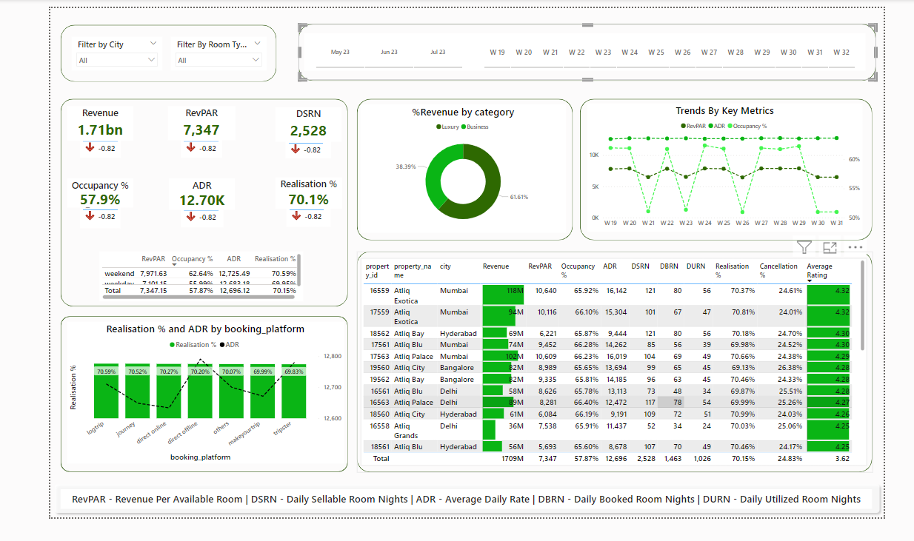

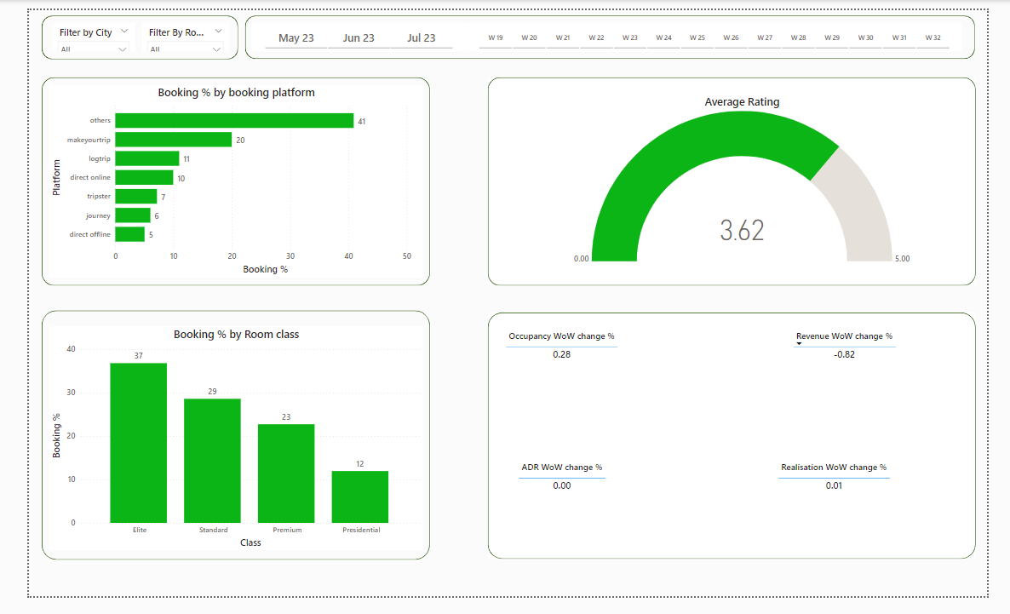

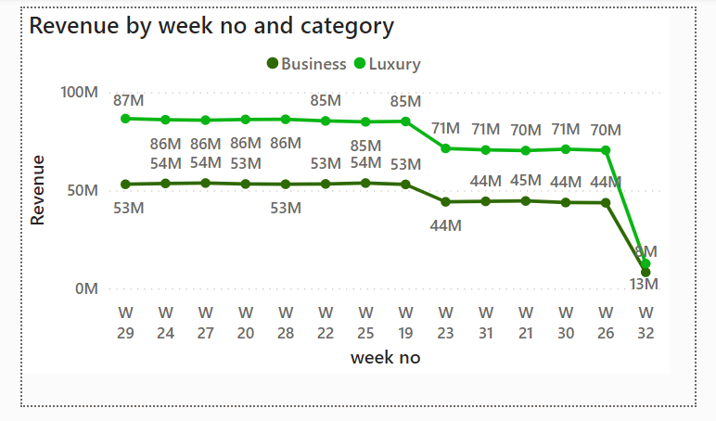

**WEEKLY CHANGES ANALYSIS:**

1. **Revenue WoW Change:** Revenue increased by -0.82% WoW, indicating negative growth.
2. **Occupancy WoW Change:** Occupancy dropped by 0.28% WoW, indicating a slight decline.
3. **ADR WoW Change:** ADR remained stable with a 0.0 % WoW.
4. **Realisation WoW Change:** Realisation improved by 0.01% WoW, signaling better utilization.

## RECOMMENDATIONS:

1. Launch targeted weekend packages to boost occupancy on Saturdays and Sundays.
2. Institute a flexible cancellation policy to mitigate revenue loss from cancellations.
3. Strengthen partnerships with Makeyourtrip to capitalize on their market share.
4. Elevate Elite room experiences with exclusive amenities to attract higher bookings.
5. Dynamic Pricing Strategy: Implement dynamic pricing based on occupancy and demand patterns. This strategy can optimize revenue by adjusting room rates in real-time, ensuring maximum profitability during peak periods and attracting budget-conscious

travelers during off-peak times.

1. Personalized Marketing Campaigns: Leverage customer data to create personalized marketing campaigns. Send tailored offers and promotions to different customer

segments, such as loyal customers, corporate clients, and leisure travelers, to enhance booking conversions.

1. Upselling and Cross-Selling: Train the front-line staff to upsell and cross-sell additional

services such as spa treatments, dining experiences, or room upgrades during the booking process or guest stay. This can contribute to incremental revenue per guest.

1. Guest Experience Enhancement: Focus on improving guest experience by investing in amenities that align with guest preferences. Implement feedback mechanisms to gather guest insights and address concerns promptly, leading to positive reviews and repeat

business.

1. Competitor Analysis: Conduct a comprehensive analysis of competitors' offerings,

pricing, and guest feedback. Identify areas where AtliQ Grands can differentiate itself and strategically position its services to attract a larger share of the market.

1. Partnerships and Collaborations: Explore collaborations with local businesses and

attractions to offer exclusive packages and experiences to guests. This can enhance the overall value proposition and encourage longer stays.

1. Seasonal Promotions: Create seasonal promotions tied to local events, holidays, or

festivals. These promotions can attract travelers seeking unique experiences and drive bookings during traditionally slow periods.

1. Enhanced Online Presence: Invest in a user-friendly and visually appealing website that showcases the hotel's features, rooms, and amenities. Implement a seamless online booking process to make it convenient for guests to secure reservations.
2. Social Media Engagement: Boost engagement on social media platforms by sharing visually appealing content, guest testimonials, and behind-the-scenes glimpses of the

hotel. Engaging with guests online can foster a sense of community and drive bookings.

1. Staff Training and Development: Provide ongoing training to staff members to enhance their customer service skills. Exceptional guest interactions can lead to positive word-of- mouth recommendations and repeat business.

## Conclusion:

In closing, this comprehensive data analysis illuminates a transformative path for AtliQ Grands, one that is underscored by insights poised to reinvigorate revenue and elevate market presence within the competitive luxury hotel landscape.

The in-depth exploration of the provided data has yielded critical revelations. A holistic view of the performance landscape reveals total realized revenue of 1.71 billion, reflective of the company's financial scope. A nuanced examination of bookings unveiled 1,463 instances, while occupancy dynamics spotlighted both the industry's challenges and potential, with an occupancy rate of 57.9% and a weekend surge reaching 62.6%. The average customer rating, at 3.6 out of 5,

serves as a compass for enhancing guest experiences. The intricate tapestry of cancellations, with a 24.8% occurrence rate, prompts strategic consideration, and Elite room popularity, representing 37% of bookings, forms a nexus for targeted growth. Moreover, the strategic landscape of booking platforms shines a spotlight on Others, driving 41% of bookings. Crucially, the Average Daily Rate (ADR) at 12,696, in tandem with 70.1% realization, aligns financial strategies with

guest value.

These insights fuel a series of actionable recommendations, designed to pivot AtliQ Grands towards growth. The spotlight on weekends and tailored promotions speaks to maximizing

occupancy during peak periods. The call for cancellation management underscores the revenue implications of a well-structured cancellation policy. Platform optimization resonates as a

beacon, amplifying partnerships with high-performing platforms. The Elite room strategy crystallizes as a potential avenue for attracting a discerning clientele.

The tangible representation of these insights is encapsulated within the dashboard showcase, poised as a versatile tool for data-driven decision-making. This visualization streamlines information dissemination, catalyzing swift and informed responses.

In the realm of fluctuating metrics, the weekly changes analysis assumes paramount importance.

Negative growth in revenue by -0.82% asserts the need for dynamic strategies. A fractional

decline in occupancy by 0.28% speaks to an evolving market. A stable ADR with 0.0% WoW underscores a consistent pricing equilibrium, while the minute improvement of 0.01% in

realization signifies incremental utilization optimization.

By embracing these insights, AtliQ Grands ushers in an era of strategic clarity. The interplay of data, insights, and recommendations lays a robust foundation for informed decision-making,

reimagining not only revenue but the very essence of market engagement and guest experiences.

This synergy shapes a future where the fusion of analysis and action forms the cornerstone of success.

As AtliQ Grands embraces this journey of transformation, the data analyst report stands as a compass, guiding the brand towards data-empowered strategies, guest-centric paradigms, and

revenue enhancement. The path ahead, illuminated by insights, invites AtliQ Grands to navigate with precision and seize the myriad opportunities that await in the dynamic hospitality landscape.